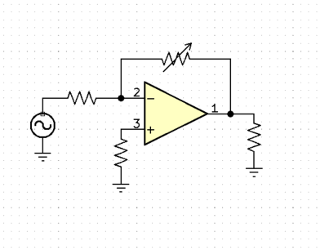

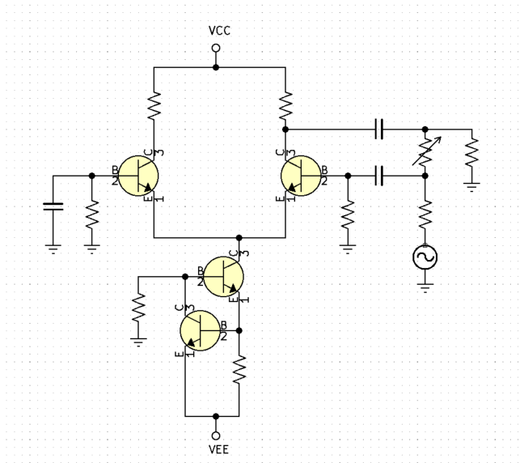**Consider the Inverting Op-Amp configuration.**

**Inverting Single Ended Differential Amplifier with Variable Gain.**

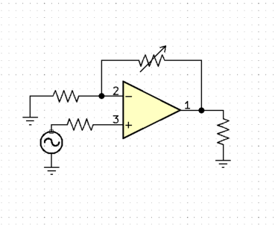

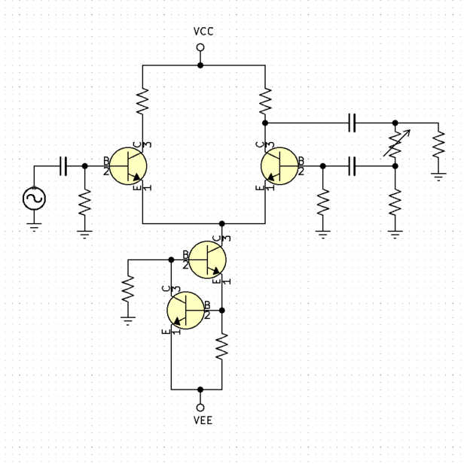**Consider the Non-Inverting Op-Amp configuration.**

**Non-Inverting Single Ended Differential Amplifier with Variable Gain.**

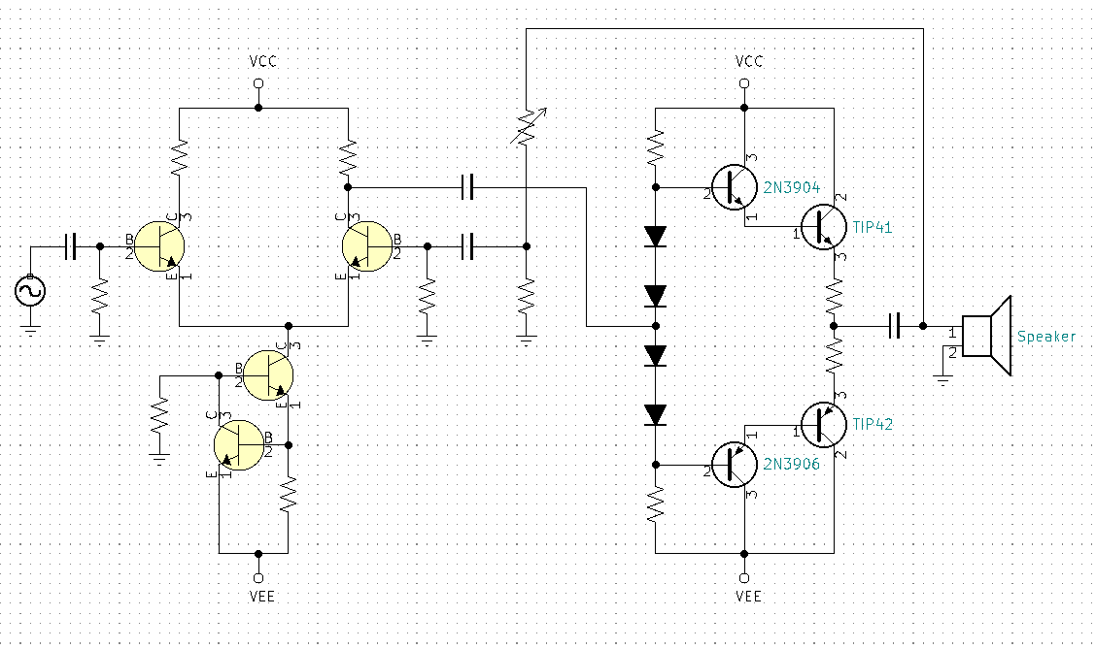

**Non-Inverting Single Ended Differential Amplifier with variable gain and Power Amplification.**